Project Design Phase-II
Technology Stack (Architecture & Stack)

Date | 31 January 3035
Team ID
Project Name
Maximum Marks | 4 Marks

Technical Architecture:
The Deliverable shall include the architectural diagram as below and the information as per the table1 & table 2
Example: Order processing during pandemics for offline mode
Reference: https://developer.ibm.com/patterns/ai-powered-backend-system-for-order-processing-during-pandemics/
Guidelines:
Include all the processes (As an application logic / Technology Block)
Provide infrastructural demarcation (Local / Cloud)
Indicate external interfaces (third party API’s etc.)
Indicate Data Storage components / services
Indicate interface to machine learning models (if applicable)
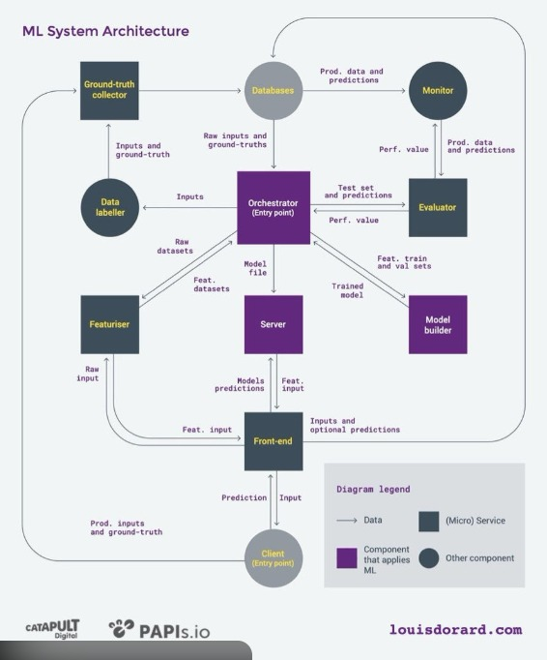
Table-1 : Components & Technologies:
S.No | Component | Description | Technology
 | User Interface | Web interface for users to enter startup details and view prediction results. | HTML, CSS, JavaScript ,Bootstrap
 | Application Logic-1 | Handles user authentication and data validation. | Python (Flask Framework)
 | Application Logic-2 | Processes startup input data and communicates with ML model. | Python
 | Application Logic-3 | Logic for a process in the application | IBM Watson Assistant
 | Database | Stores user details and prediction history. | SQLite / MySQL
 | Cloud Database | Database Service on Cloud | IBM DB2, IBM Cloudant etc.
 | File Storage | Stores trained ML model file (.pkl) | Local File System
 | External API-1 | Fetch startup-related external data. | REST API
 | External API-2 | Purpose of External API used in the application | Aadhar API, etc.
 | Machine Learning Model | Predicts startup success probability based on input features. | Scikit-learn (Logistic Regression / Random Forest)
 | Infrastructure (Server / Cloud) | Deployment of web application. | Local Server / Render / Heroku / AWS

Table-2: Application Characteristics:
S.No | Characteristics | Description | Technology
 | Open-Source Frameworks | Uses open-source libraries and frameworks. | Flask, Scikit-learn, Pandas, NumPy
 | Security Implementations | User authentication and password encryption. | Flask-Login, Password Hashing (SHA-256), HTTPS
 | Scalable Architecture | Three-tier architecture allows scaling of backend and database independently. | Flask + Cloud Deployment
 | Availability | Application hosted online to allow 24/7 access. | Cloud Hosting Platform
 | Performance | Optimized ML model for quick prediction. Minimal response time. | Efficient Python processing, Optimized ML model

References:
https://c4model.com/
https://developer.ibm.com/patterns/online-order-processing-system-during-pandemic/
https://www.ibm.com/cloud/architecture
https://aws.amazon.com/architecture
https://medium.com/the-internal-startup/how-to-draw-useful-technical-architecture-diagrams-2d20c9fda90d

